State Pattern
# Source: AI Source: Provided by: [Data Path: Persons Table -> ID Column: 1, Name_En Column: Motasem Essam] -> From: [ChatGPT] on [1/23/2026]
The State Pattern allows an object to change its behavior when its internal state changes, making it appear as if the object changed its class.
👉 Think of it like a traffic light: its behavior changes based on its current state (Red, Yellow, Green).

🔑 Key Points
# Source: AI Source: Provided by: [Data Path: Persons Table -> ID Column: 1, Name_En Column: Motasem Essam] -> From: [ChatGPT] on [1/23/2026]
• Encapsulates state-specific behavior into separate classes
• Eliminates large conditional statements
• Object behavior changes dynamically at runtime
• Promotes clean and maintainable code

❌ Bad Example
# Source: AI Source: Provided by: [Data Path: Persons Table -> ID Column: 1, Name_En Column: Motasem Essam] -> From: [ChatGPT] on [1/23/2026]
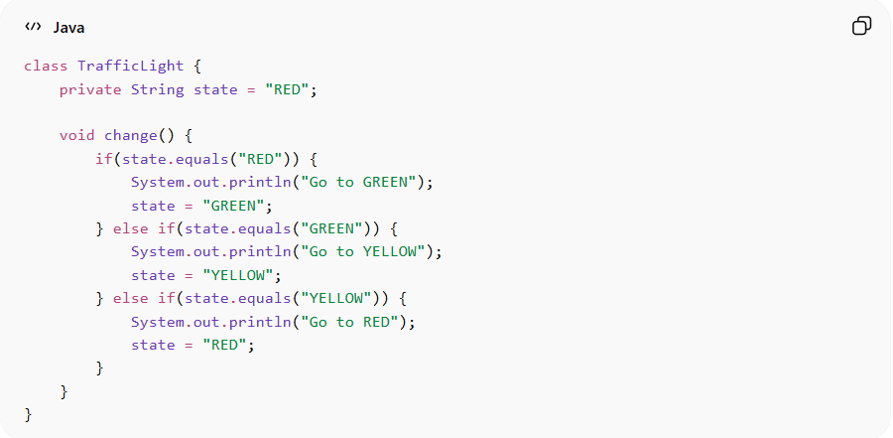
class TrafficLight {
private String state = "RED";

void change() {
if(state.equals("RED")) {
System.out.println("Go to GREEN");
state = "GREEN";
} else if(state.equals("GREEN")) {
System.out.println("Go to YELLOW");
state = "YELLOW";
} else if(state.equals("YELLOW")) {
System.out.println("Go to RED");
state = "RED";
}
}
}
Problems:
• Uses multiple if/else conditions
• Hard to extend with new states
• Violates Open/Closed Principle

✅ Good Example
# Source: AI Source: Provided by: [Data Path: Persons Table -> ID Column: 1, Name_En Column: Motasem Essam] -> From: [ChatGPT] on [1/23/2026]
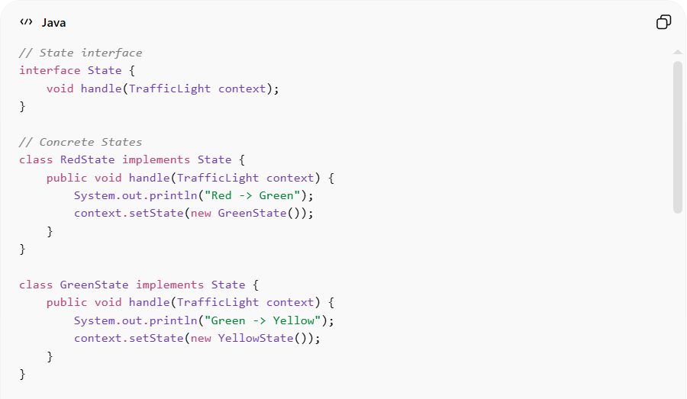
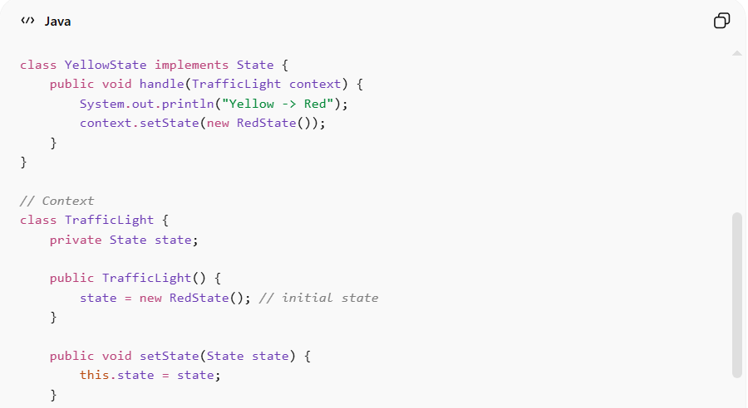
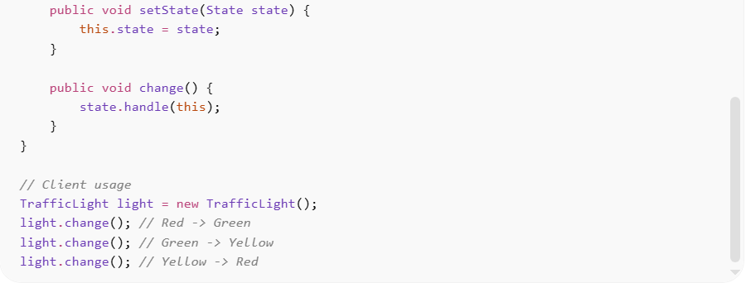
// State interface
interface State {
void handle(TrafficLight context);
}

// Concrete States
class RedState implements State {
public void handle(TrafficLight context) {
System.out.println("Red -> Green");
context.setState(new GreenState());
}
}

class GreenState implements State {
public void handle(TrafficLight context) {
System.out.println("Green -> Yellow");
context.setState(new YellowState());
}
}

class YellowState implements State {
public void handle(TrafficLight context) {
System.out.println("Yellow -> Red");
context.setState(new RedState());
}
}

// Context
class TrafficLight {
private State state;

public TrafficLight() {
state = new RedState(); // initial state
}

public void setState(State state) {
this.state = state;
}

public void change() {
state.handle(this);
}
}

// Client usage
TrafficLight light = new TrafficLight();
light.change(); // Red -> Green
light.change(); // Green -> Yellow
light.change(); // Yellow -> Red
Benefits:
• Removes complex conditional logic
• Makes it easy to add new states
• Improves readability and maintainability
• Behavior is encapsulated and reusable

⚡ Advantages
# Source: AI Source: Provided by: [Data Path: Persons Table -> ID Column: 1, Name_En Column: Motasem Essam] -> From: [ChatGPT] on [1/23/2026]
• Simplifies state-dependent logic
• Promotes open/closed principle
• Makes transitions clear and organized
• Improves code flexibility

⚠️ Disadvantages
# Source: AI Source: Provided by: [Data Path: Persons Table -> ID Column: 1, Name_En Column: Motasem Essam] -> From: [ChatGPT] on [1/23/2026]
• Increases number of classes (one per state)
• Can be overkill for simple state logic
• Slight overhead in managing state objects

🛠️ Use Cases
# Source: AI Source: Provided by: [Data Path: Persons Table -> ID Column: 1, Name_En Column: Motasem Essam] -> From: [ChatGPT] on [1/23/2026]
• Traffic light systems
• Game characters – different states (idle, running, attacking)
• Order processing systems – pending, shipped, delivered
• UI elements – enabled, disabled, focused states

